**AUTOMATING TRAFFIC MICROSIMULATION FROM SYNCHRO UTDF TO SUMO**

Xiangyong Luo1, Yiran Zhang2, Guanhao Xu1, Wan Li1, Ross Wang1 and Xuesong Simon Zhou3

1 Buildings & Transportation Science Division, Oak Ridge National Laboratory (ORNL), Oak Ridge, TN

2 The Intelligent Urban Transportation System (iUTS) Lab, Department of Civil and Environmental Engineering, University of Washington, United States

3 School of Sustainable Engineering and the Built Environment, Arizona State University, 660 S. College Avenue, Tempe, AZ 85287-3005, USA

ABSTRACT

Modern transportation research relies on seamlessly integrating traffic signal data with robust network representation and simulation tools. We present utdf2gmns, an open-source Python tool that automates the conversion of Synchro’s UTDF Format, including network representation, signalized intersections, turning volumes into the GMNS Standard. The resulting GMNS-compliant network can be used for simulation in SUMO. By automatically extracting intersection control parameters and aligning them with GMNS conventions, utdf2gmns minimizes manual preprocessing and reduces data loss. It also integrates with the sigma-x engine to extract and visualize key traffic control metrics such as phasing diagrams, turning volumes, movement capacities, volume-to-capacity (V/C) ratios, and control delays. This streamlined workflow enables efficient scenario testing, accurate model building, and consistent data management. Validated through case studies, utdf2gmns reliably models complex urban corridors. As a free, open-source solution, it promotes reproducibility and standardization. Documentation is available on [GitHub](https://github.com/xyluo25/utdf2gmns) and [PyPI](https://pypi.org/project/utdf2gmns/), supporting easy integration and community engagement.

# INTRODUCTION

Traffic microsimulation is essential for evaluating and enhancing urban transportation systems, providing insights into traffic flow management, congestion mitigation, and infrastructure improvements. Accurate simulations require precise representation of traffic signals, network geometries, and turning movements. However, conventional approaches to preparing simulation-ready networks, particularly from popular tools such as Synchro, remain largely manual and error-prone. Synchro's Universal Traffic Data Format (UTDF) provides comprehensive intersection data but lacks efficient interoperability with microsimulation software, leading to labor-intensive data preparation, potential inaccuracies, and inconsistencies.

Several critical challenges persist in effectively converting Synchro UTDF data into microsimulation-compatible networks. One primary challenge is signal conversion. Translating intersection control parameters accurately into standardized formats involves detailed extraction, interpretation, and alignment of signal phasing, timing, and coordination data. Inaccuracies in this step can significantly affect the reliability of simulation outputs, underscoring the necessity for precise and automated methods. Another substantial challenge involves network conversion. Synchro typically utilizes relative coordinate systems, which must be converted into real-world geographic coordinates (longitude and latitude) for effective integration with Geographic Information Systems (GIS). This conversion process is often tedious, error-prone, and requires considerable manual effort, complicating large-scale or complex network simulations. Additionally, accurate turning flow conversion is essential for realistic simulation of intersection dynamics. Converting turning movement data, which is crucial for capturing the complexity of urban traffic interactions, frequently involves extensive manual preprocessing. Imprecise conversion in this stage can propagate through simulations, compromising the accuracy and usefulness of the resulting analyses.

Existing research and implementations have not yet provided comprehensive solutions to all the identified challenges simultaneously. Zhang (2024) introduced a method to convert Synchro signal data to a SUMO network; however, this conversion requires preliminary preparation of both the Synchro UTDF file and the SUMO network separately. Coogan (2021) conducted an early effort to convert Synchro's geometric and phasing data into SUMO, primarily emphasizing geometry conversion. Nevertheless, their network conversion employed relative coordinates and was limited to selected intersections, lacking automation and scalability for broader application. Ban (2022) converted Synchro signal data into SUMO to facilitate calibration within a vehicle-traffic-demand (VTD) simulation platform; however, the networks used in Synchro and SUMO were prepared independently and differently. Udomsilp (2017) leveraged Synchro for optimizing network signal timings, specifically cycle lengths, and subsequently employed these optimal cycle lengths as inputs into SUMO simulations to evaluate travel-time improvements. Similarly, Singh (2017) utilized Synchro for traffic signal optimization, incorporating optimal green times into SUMO simulations to assess start-up lost times. Despite these contributions, a fully integrated and automated solution remains lacking in current literature.

To address these gaps, we introduce utdf2gmns (Figure 1), an open-source Python tool designed to automate the conversion of Synchro UTDF files into GMNS-compliant (General Modeling Network Specification) networks suitable for simulation in the widely used SUMO platform. By combining the advantages of the GMNS, a robust framework that standardizes network representation, enhancing data consistency, reproducibility, and collaboration, utdf2gmns specifically contributes through the following functionalities: (1) Automatic Geocoding of Synchro Networks: Automates the transformation of relative coordinates into precise longitude and latitude, significantly reducing manual effort and ensuring accurate spatial representation compatible with GIS. (2) Enhanced Sigma-X Engine Integration: Leverage the sigma-x engine to automatically extract, calculate, and visualize essential signalized intersection metrics. This includes detailed phasing diagrams, turning volume statistics, movement capacities, volume-to-capacity (V/C) ratios, and intersection control delays, providing comprehensive analysis and facilitating informed decision-making. (3) Robust SUMO Network Generation: Carefully generates GMNS-compliant SUMO simulation networks by fully considering critical parameters such as signal coordination, traffic flows, and turning movements, thus accurately reflecting real-world operational scenarios. (4) Extendibility to Other Microsimulation Platforms: Built as an open-source modular tool, utdf2gmns enables easy adaptation and extension to additional simulation software platforms beyond SUMO. This promotes broader standardization, reproducibility, and community-driven enhancement in traffic simulation research.



Design Framework of utdf2gmns

# METHODOLOGY

To accurately and automatically convert Synchro networks (in UTDF format) into SUMO for extended microsimulation, several critical aspects must be addressed. These include converting the original network coordinates from relative to real-world geographical coordinates (longitude and latitude), extracting and translating signal information from the original files into SUMO-compatible formats, converting turning flow data, and calculating essential performance metrics. The methods presented in this chapter aim to systematically resolve these issues.

## 2.1 Network Coordinating

The first and most critical step in the automation process is converting the Synchro network into a real-world network that can be accessed using GIS and other simulation software. In this section, we introduce two methods to transform the original network into a universally readable format. The first method automatically geocodes intersections, while the second method requires manually inputting the coordinate of one intersection.

### 2.1.1 Automatic Geocoding

The UTDF file provides directional link names for each intersection. The logic for coordinate validation (Figure 2) involves iterating through each intersection and extracting directional names, then applying a double-confirmation approach to validate the intersection's coordinates. If valid coordinates for an intersection are confirmed, the iteration stops; otherwise, the process continues to the next intersection. In the worst-case scenario, where no valid coordinates are identified, the program will prompt the user to confirm the network’s location visually or switch to the manual geocoding method. After successfully validating coordinates for one intersection, all remaining intersections are mapped by converting their relative coordinates into real-world positions based on the validated reference point.



Figure 1 Two methods of coordinating intersections

### 2.1.2 Manual Geocoding with One Given Coordinate

Manual geocoding requires minimal effort, as only one coordinate is necessary. In this step, users only need to provide a single intersection ID paired with its coordinates (e.g., {"INTID": intersection ID, "coord_x": longitude, "coord_y": latitude}). As illustrated in Figure 1, once the coordinate of one intersection is confirmed, the program uses this reference point to geocode all other intersections accordingly.

## 2.2 Signal Conversion

Signal information is essential for microsimulation, and accurately converting signal data from Synchro to SUMO plays a crucial role in the automation process. Correctly converted signals enable SUMO to leverage its extensive functionalities for traffic control and optimization. In this paper, we collect detailed information about Phases, Timeplans, and Lanes from the UTDF file. These details include BRP, MinGreen, MaxGreen, VehExt, Yellow, AllRed, and Recall for Phases; ControlType, CycleLength, and Offset for Timeplans; and protected and permitted phases for Lanes.

Direction Mapping: Before conversion, mapping traffic movement directions between Synchro and SUMO is required. Synchro has predefined movement directions (Figure x), whereas SUMO represents traffic signal states ('tlLogic') as strings, with each character corresponding to a specific lane-to-lane movement. Our method involves converting edge slopes into Synchro-compatible directions and associating this information with SUMO. The vehicular traffic-bound direction in SUMO is then determined by combining turning directions from connection data with the previously assigned traffic-bound directions, following a right turn (R), through (T), and left turn (L) order. Unlike vehicular movements, pedestrian crossings lack unique bound directions, as pedestrians can cross intersections bidirectionally (e.g., Eastbound to Westbound and vice versa). Pedestrian bounds are identified starting with the crossing edges corresponding to the initial vehicular bound direction in SUMO. Therefore, identifying corresponding vehicular crossing edges is essential for accurately defining pedestrian crossings.

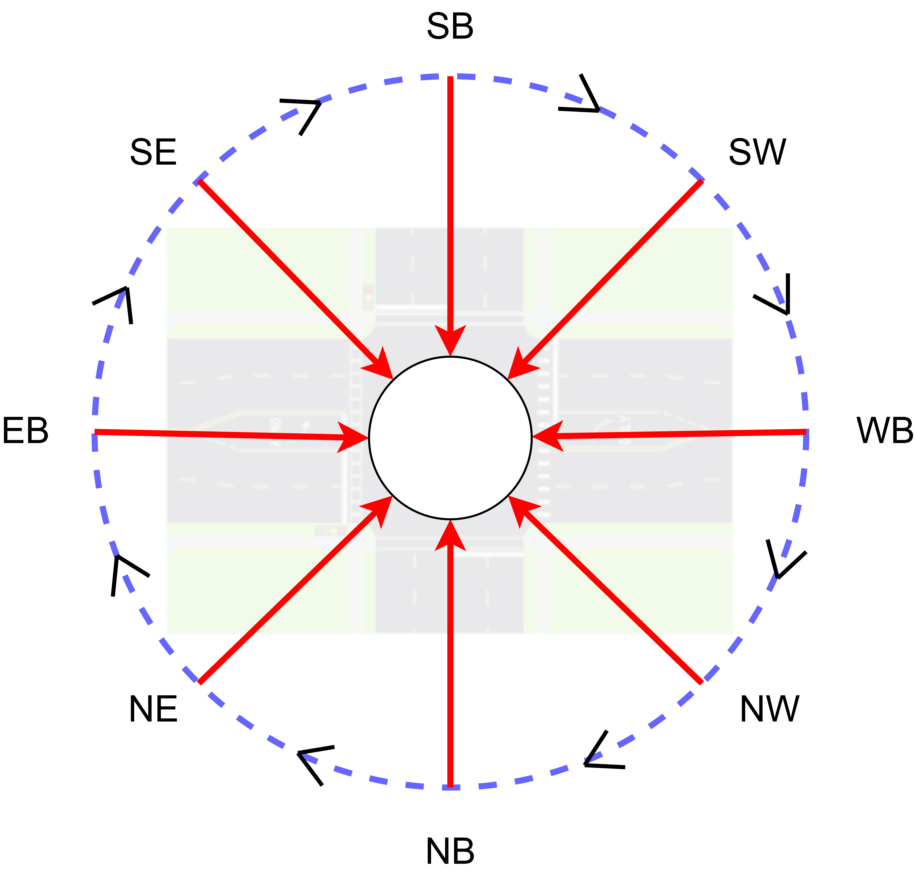

Figure 1: Direction order in Synchro

Phase mapping. After establishing direction mappings, signal phase mapping is conducted. This step organizes signal phase orders and generates lane-based signal states. SUMO and Synchro differ in how signal phases are configured. Synchro employs a Ring-and-Barrier Designer for simulating ring-barrier controllers, automatically managing phase transitions based on Barrier, Ring, and Position (BRP) assignments. In contrast, SUMO uses a state-based string, where each character represents a signal color (Green (G/g), Yellow (y), Red (r)), with uppercase indicating protected movements and lowercase indicating permitted movements. SUMO supports various controller models, including pre-timed, actuated, and NEMA-type controllers for Dual-Ring-Barrier control signals [19], [20]. However, real-world scenarios often involve complex configurations, such as multiple rings or specialized pedestrian crossings. Our methodology is demonstrated using a Ring-Barrier-Controlled signal with three rings as an example. Initially, all valid phases are extracted from Synchro. Next, a Breadth-First Search algorithm is applied to identify feasible combinations of green phases. Using Connection-to-Direction mapping, Synchro phase numbers are translated into SUMO lane-based states by correlating SUMO’s link index with corresponding Synchro Lane groups. Finally, bitwise comparisons between adjacent green phases are performed, supplemented by interpolations of yellow and all-red phases to ensure smooth transitions and precise signal timing.

## 2.3 Traffic Flow Conversion

Turning volumes from the UTDF file are indicated in vehicles per hour. In Synchro, turning volumes are specified individually for each direction (Left, Through, Right, and U-Turn). However, SUMO automatically generates U-turn volumes for all possible connections, which could negatively affect the accuracy of the network conversion. To address this, we allow U-turns in the converted SUMO network only if they are explicitly specified in the UTDF file. In this section, we extract left, through, and right turning volumes from the UTDF file and generate the corresponding flow files for SUMO.

## 2.4 Sigma-X Powered Performance Calculation

Sigma-X is a powerful engine developed in VBA by Prof. Milan at the University of Wyoming. The original development took place from 2012 to 2022 under a GNU License. We resumed development in 2025 to address issues in handling large and complex networks and to enhance result management and control. Sigma-X extracts intersection volumes, signals, inbound and outbound traffic flows, links, and lane configurations. It then calculates and visualizes key metrics for signalized intersections, including volume-to-capacity (V/C) ratios, Level of Service (LOS), turning volumes, signal phasing, control delays (seconds), split durations (seconds), movement capacities (vehicles per hour), and more.

### 2.4.1 Overview of Signalized Intersection

The overview of the signalized intersection will combine extracted and calculated parameters into one figure with centralized with the intersection name. Figure 1 shows the sample overview features. As shown in the figure, the center will show the intersection name, then from center extended with movement directions for each direction. There are number of lanes and volumes are corresponding to each movement and will be updated from UTDF data. The right turn on read (RTOR) specified for each right turn lane as well. Then speed will be updated as well, such EB Speed, WB Speed, NB Speed and SB Speed. For each direction, the street name will also be updated.

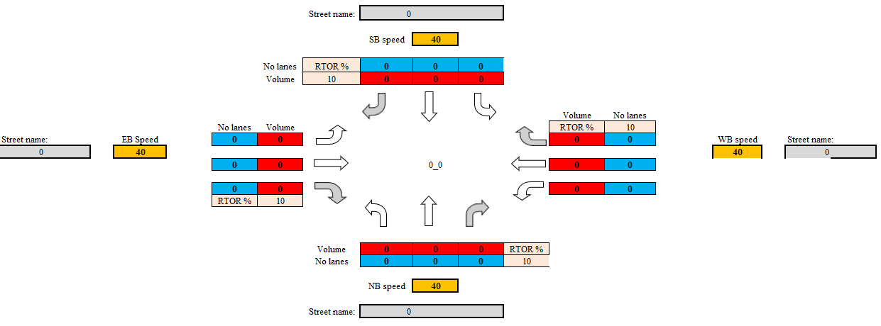

Figure 1 Overview of the signalized intersection

### 2.4.2 Signal Phasing

signal phasing information is extracted and processed from Synchro UTDF files, which provide detailed signal timing parameters such as cycle length, phase splits, offsets, and protected/permissive movements. These raw data are parsed to reconstruct the operational logic of traffic signals at each intersection, offering insight into how signal phases are coordinated across the network.

After extraction, the processed signal phasing data are used to generate visual representations in the form of phase timing charts. These charts display the sequence and duration of each phase within a cycle, highlighting overlaps and coordination opportunities between adjacent intersections. This visualization not only aids in the verification of signal timing consistency but also supports further analyses such as delay estimation, progression evaluation, and scenario simulation under varying traffic conditions.

### 2.4.3 Turning Volume and Number Lanes

Turning volume data provide essential insight into intersection-level traffic dynamics by capturing the directional flow of vehicles—such as left turns, through movements, and right turns—at each approach. In this study, turning volume information is extracted directly from Synchro UTDF (Universal Traffic Data Format) files, which include detailed counts for each movement during peak periods. These data allow for a precise understanding of demand distribution and intersection load across the network.

To facilitate interpretation, the extracted turning volumes are visualized using movement-specific charts that depict traffic flow intensity by direction. These charts help identify imbalances in movement demand, potential bottlenecks, and critical turning movements that may require signal timing adjustments or geometric improvements. By presenting the turning volumes in a clear and intuitive format, the analysis supports more informed decision-making in traffic signal optimization and intersection design.

### 2.4.4 V/C Ratio and Movement Capacity (VPH)

The Volume-to-Capacity (V/C) ratio is a key performance indicator used to evaluate the operational efficiency and level of service at signalized intersections. In this study, V/C ratios are derived from Synchro UTDF (Universal Traffic Data Format) data, which include traffic volumes and lane capacities for each movement. By calculating the V/C ratio for individual movements and approaches, the analysis quantifies the degree of congestion and identifies locations where demand approaches or exceeds available capacity.

The Volume-to-Capacity (V/C) ratio is a key performance metric for evaluating intersection performance.

In this study, the V/C ratio is calculated using data extracted from Synchro UTDF files, which provide detailed traffic volumes and lane capacities for each movement. This ratio quantifies the degree of saturation at an intersection, with higher values indicating potential congestion. Visual charts generated from the V/C data highlight critical movements where demand approaches or exceeds capacity, serving as an essential diagnostic tool for identifying intersections that may require signal optimization or capacity enhancements.

In addition to the V/C ratio, movement capacity is assessed to gain deeper insight into the operational limits of each intersection movement. Movement capacity represents the maximum number of vehicles that can be processed by a specific approach under prevailing signal timing and geometric conditions. By analyzing both V/C ratios and movement capacities together, the study provides a comprehensive view of intersection performance, allowing for a more precise identification of areas where traffic flow improvements are needed. The visualizations further aid in comparing the actual demand against the theoretical capacity, thereby supporting targeted interventions to enhance overall network efficiency.

To enhance interpretability, the computed V/C ratios are presented through visual charts that illustrate the performance of each intersection. These charts highlight critical movements with high V/C ratios, indicating potential delays or capacity shortfalls. Such visualization supports quick identification of problem areas within the network and serves as a basis for prioritizing signal optimization, capacity enhancements, or geometric redesigns.

### 2.4.5 Level of Service and Control Delay

Level of Service (LOS) is a standardized metric used to evaluate traffic performance at signalized intersections, reflecting the quality of traffic flow experienced by drivers. LOS is categorized into six levels, from A to F, where LOS A represents minimal delays and high operating efficiency, and LOS F indicates excessive delays and breakdown conditions. In this study, LOS is determined in accordance with the methodologies defined in the Highway Capacity Manual (HCM 6th Edition), which classifies LOS based on control delay per vehicle measured in seconds. Control delay measures the additional travel time a vehicle experiences at an intersection compared to uninterrupted flow. By applying methodologies outlined in the Highway Capacity Manual (HCM), control delay thresholds are used to assign each approach an appropriate LOS category, providing a quantitative measure of operational efficiency.

Using data extracted from Synchro UTDF files—such as approach volumes, lane configurations, and signal timing—control delays are calculated, and corresponding LOS values are assigned for each approach and intersection. The LOS results are then visualized through intuitive charts that highlight operational efficiency across the network. The calculated LOS values, along with their corresponding control delays, are visualized through detailed charts. These charts not only depict the overall level of service at various intersections but also highlight the specific delays contributing to suboptimal performance. Such visualizations enable traffic engineers to quickly identify intersections experiencing high control delays (e.g., LOS E or F), thereby informing targeted interventions such as signal retiming, lane reconfigurations, or other capacity enhancements to improve network performance.

### 2.4.6 Split Durations (Seconds)

Split duration refers to the allocation of green time among different signal phases within a cycle at a signalized intersection. It is a critical parameter in signal timing that directly influences intersection performance, delay, and traffic progression. In this study, split durations are extracted and calculated from Synchro UTDF (Universal Traffic Data Format) files, which contain detailed signal timing plans including green, yellow, and red intervals for each phase.

The extracted split durations are used to generate visual charts that illustrate how green time is distributed across different movements within each cycle. These charts help to assess the balance between traffic demand and signal timing, highlighting potential inefficiencies such as over- or under-allocated phases. Such visualization supports informed adjustments to signal timing plans, promoting more effective utilization of intersection capacity and smoother traffic flow.

## 2.5 SUMO Generation

SUMO network will be generated by using netconvert, jrrouter tools. There are several steps to automatically convert Synchro network to SUMO network. AS we have geocoded intersections, we will then be geocoding links and lanes from the intersections. After network have been created, the next step is to integrating signal to the generated network. Then the flow data could be converted by configuring the turning for the sumo network. The last step is to generate the SUMO configuration file for simulation in sumo.

### 2.5.1 Network Conversion

As we have the real-world coordinates of intersections, we create nod.xml file in SUMO format. The next step is to generate the links and lanes from the intersections. We will create an edg.xml file in SUMO format. Then by combing nod.xml and edg.xml, using netconvert tool to create net.xml. We can create links and lanes with default width (From UTDF data).

### 2.5.2 Signal Integration

After the generated the network, the signal integration is implemented. The updated signal information is on net.xml.

### 2.5.3 Turning Configuration

The first step is to generate flow.xml file from turning volumes in the UTDF. According to the flow.xml and net.xml, using jtrrouter tool to generate rou.xml file. To correctly integrate turning flow from Synchro to SUMO, there are some constraints need to update. In the creation of rou.xml, we need to forbit loops to avoid vehicles going out at the dead-end route and come back at the dead-end route then. After the rou.xml files generated, we need to invalid U-turn in the network. The reason to invalid U-turn is because the Synchro network does not include U-turn information in the most cases and the SUMO network generation will always generate U-turn from given nod.xml and edg.xml. The additional U-turn volumes will be casing the simulation in SUMO getting wrong.

### 2.5.4 SUMO Configuration

After SUMO network file generated, we extract the staring time and duration from UTDF and crate SUMO configuration file for microsimulation.

# CASE STUDY

## 3.1 Study Area

This study selects downtown Tempe as the study area, as depicted in Figure 1,

There are 755 intersections in the network with 227 signalized intersections.

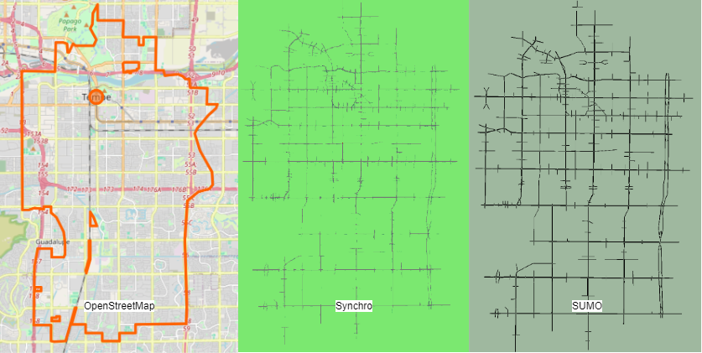

Figure 1: City of Tempe showing in OpenStreetMap, Synchro network and SUMO network (order from left to right)

illustrates the complexity of intersections within a large-scale network, highlighting the challenges associated with integrating Synchro and SUMO. The network features a range of intersection types, extending beyond the conventional four-way to include three-way and even five-way and six-way intersections. Additionally, the presence of signal protection at these intersections varies greatly, encompassing factors such as pedestrian phases, protected left or right turns, and different signal timing plans ranging from fixed to adaptive and actuated timing. This diversity significantly complicates the process of implementing integration between Synchro and SUMO, as each intersection type and signalization approach demands careful consideration and unique handling within the simulation models.

## 3.2 Automation in Intersection Key Features Visualization

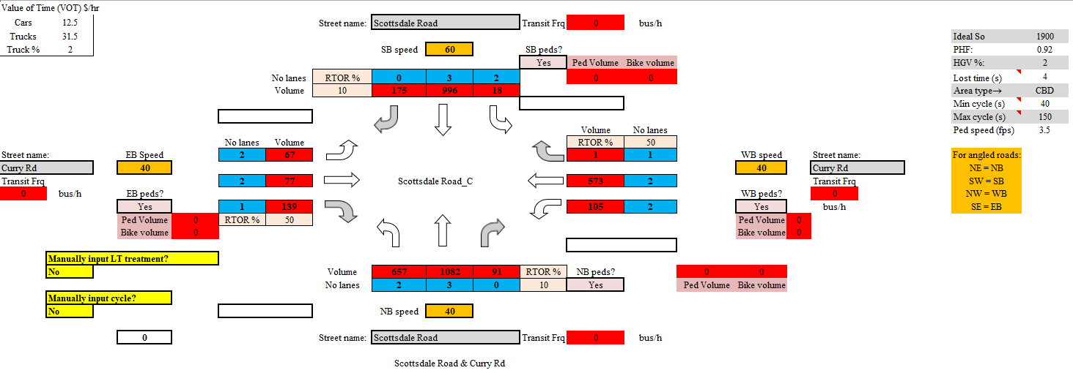

Overview of signalized intersection

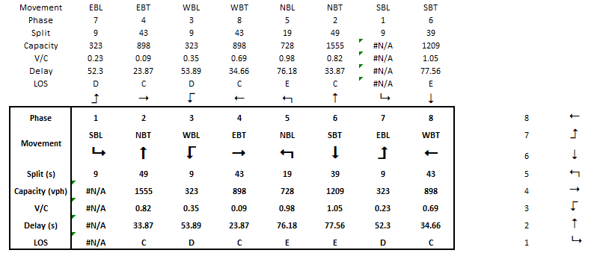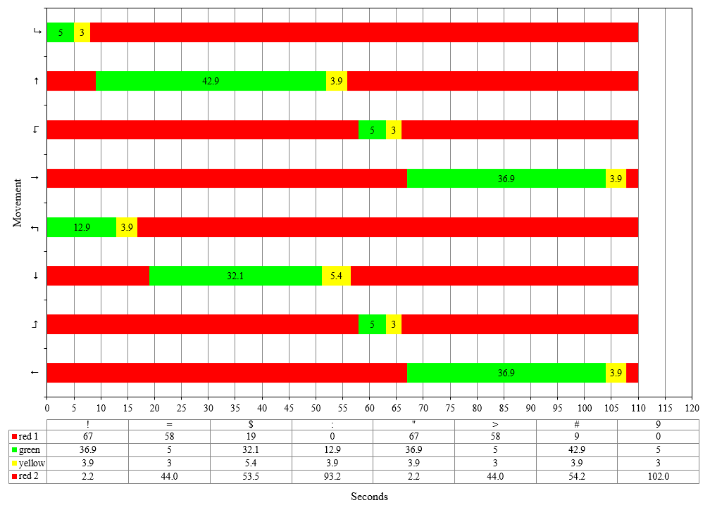

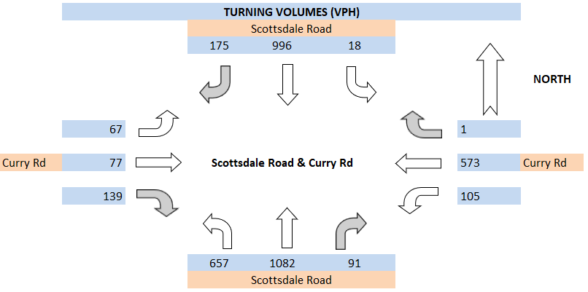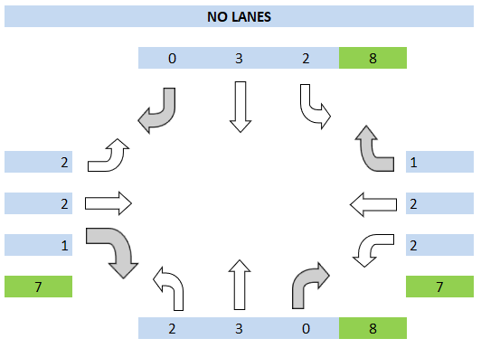

v/c ratio

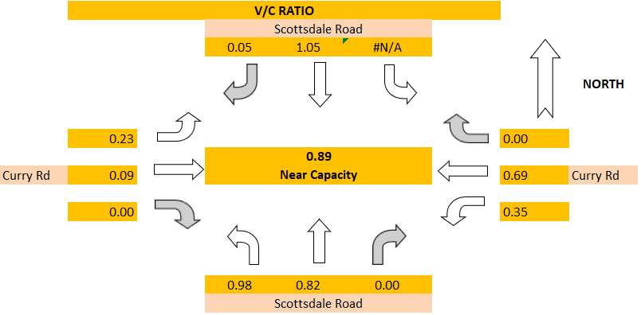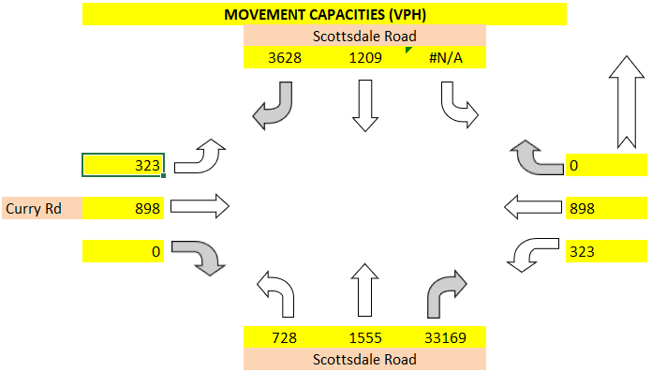

Los control delay

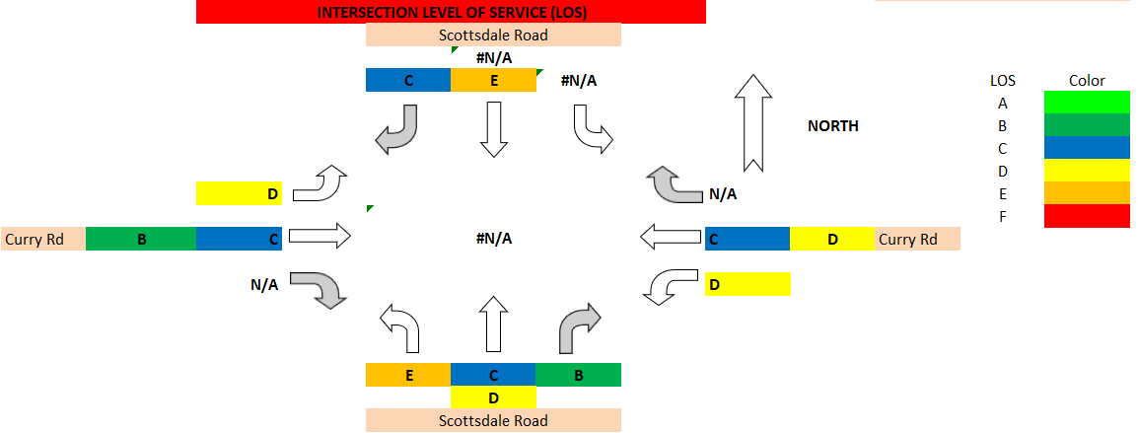

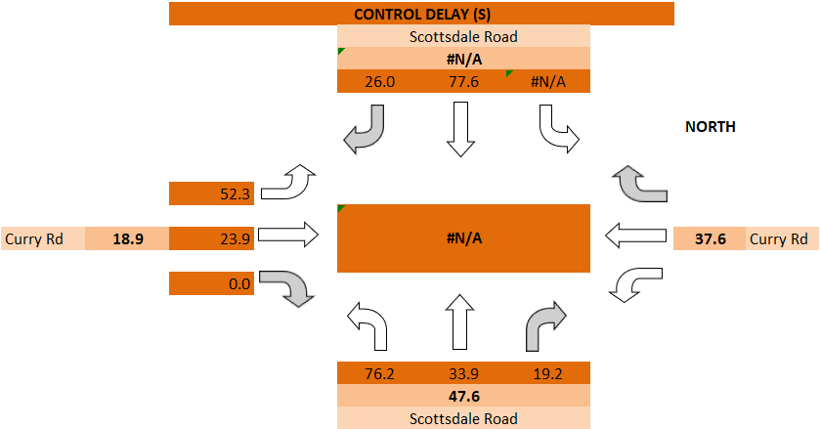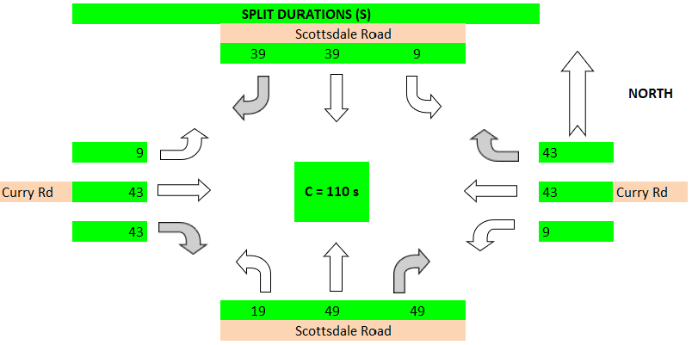

Split durations

## 3.3 Automation in SUMO Microsimulation

### 3.3.1 Network

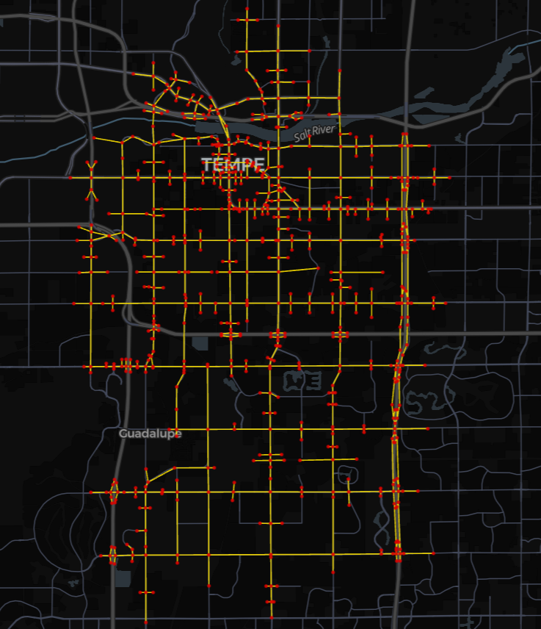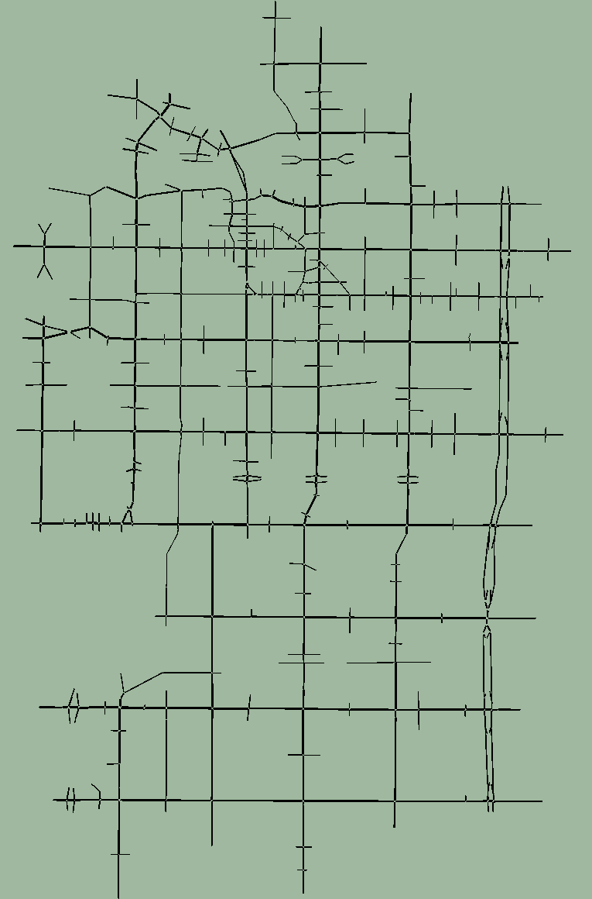

### 3.3.2 Intersection Features

### 3.3.3 Signal and Turning Flow

# CONCLUSION AND FUTURE WORK

In this paper, we explored the process of integrating traffic signal data from Synchro to SUMO, identifying both the feasibility and challenges involved. Our approach began with a comparative analysis of traffic network features, data formats, and signal timing schemas between the two platforms. Despite similarities in road network features, significant differences in traffic signal timing plan encodings presented obstacles, especially in large-scale networks.

To overcome these challenges, we introduced a four-stage approach encompassing Data Preparation, Connection-to-Direction Mapping, Signal Phase Mapping, and Data Revision and Output. This methodology focused on extracting relevant signal timing and road features, aligning inbound directions, and generating lane-specific signal states for each timing phase. We then converted this data into SUMO's XML format. Our semi-automated pipeline, developed in Python, was tested on two Synchro models in downtown Seattle. The success rate exceeded 85%, demonstrating the pipeline's ability to handle various intersection layouts and signal controller types. However, the integration is not flawless in large-scale networks, necessitating manual checks for complex intersections.

The proposed four-stage approach can help researchers and modelers integrate the signal timing data from Synchro to SUMO more efficiently. This study delved into the intricacies of signal control mechanisms within both platforms. For future work, this framework could be foundational for extending traffic signal integration from Synchro/SUMO to other platforms. While the results in large-scale networks are promising, they still require manual validations and revisions in complex scenarios, such as the mismatching geometry coding between Synchro and SUMO and intersections with an exclusive pedestrian phase. Further refinement through specific algorithms is needed to enhance signal integration accuracy. Additionally, we envision supporting the integration of advanced signal control features, such as coordinated signal control, to elevate the quality of simulation. Beyond traffic signal control integration, this four-stage approach may hold the potential for integrating a wider range of Synchro features into SUMO, including links, routes, and detectors.

ACKNOWLEDGMENTS

Place the acknowledgments section, if needed, after the main text but before any appendices and references. The section heading is not numbered. These instructions are adapted from instructions that have been iteratively updated and improved by proceedings editors and several other individuals, who are too numerous to name separately, since the first set of instructions was written by Barry Nelson for the 1991 WSC.

REFERENCES

Zhang, Y., Fu, M. and Ban, X., 2024, July. Integration Traffic Signal Control From Synchro to SUMO. In SUMO Conference Proceedings (Vol. 5, pp. 147-162).

Coogan, S. and Thitsa, M., 2021. Coordinated Anti-Congestion Control Algorithms for Diverging Diamond Interchanges (No. FHWA-GA-21-1913). Georgia. Department of Transportation. Office of Performance-Based Management & Research.

Ban, J., Angah, O., Zhang, Y. and Guo, Q., 2022. A multiscale simulation platform for connected and automated transportation systems.

Udomsilp, K., Arayakarnkul, T., Watarakitpaisarn, S., Komolkiti, P., Rudjanakanoknad, J. and Aswakul, C., 2017. Traffic data analysis on sathorn road with synchro optimization and traffic simulation. Engineering Journal, 21(6), pp.57-67.

Singh, S.K., Komolkiti, P. and Aswakul, C., 2017. Impact analysis of start-up lost time at major intersections on sathorn road using a synchro optimization and a microscopic SUMO traffic simulation. IEEE Access, 6, pp.6327-6340.

AUTHOR BIOGRAPHIES

Author biographies are mandatory for all authors and given in the same sequence as in the running head. Use a smaller font (9 pt) with a 10.5pt line spacing (MS Word style AuthorBio). Giving an email address is mandatory and the author’s name is set in bold capitals (see the examples below). Separate the authors by an empty line with the same style. Give only one paragraph per author but sufficient information to understand the author’s position and scientific background.

**ELIE AZAR** is a Canada Research Chair and Associate Professor in the Department of Civil and Environmental Engineering at Carleton University in Ottawa, Canada. His research interests include human-centered building design and operation, occupant behavior modeling, building performance simulation, agent-based modeling, and data-driven predictive models. He has authored numerous scientific research articles in his field and edited books focused on sustainability, smart cities, and artificial intelligence. His email address is [elie.azar@carleton.ca](mailto:elie.azar@carleton.ca) and his website is <https://carleton.ca/cee/profile/elie-azar/>.

**ANATOLI DJANATLIEV** is an Associate Professor for Computer Science at the University of Applied Sciences Ingolstadt. He received his Ph.D. degree (Dr.-Ing.) and his M.Sc. in computer science (Dipl.-Inf. Univ.) from the engineering faculty of the University of Erlangen-Nuremberg in 2015 and 2008, respectively. Until 2010, he worked as a software engineer within the area of model-based testing and automated test case generation. Thereafter, he was leading a research grop for Connected Mobility at the University of Erlangen-Nuremberg. His previous research focus was related to prospective assessments of health technologies, and healthcare decision-support. His current research interests include various topics on simulation and modeling using agent-based simulation, and hybrid simulation. Major application areas are simulation of healthcare systems, vehicular networks, innovative aspects of connected mobility, and future mobility services. His email address is [anatoli.djanatliev@thi.de](mailto:anatoli.djanatliev@thi.de) and his website is <https://www.thi.de/en/computer-science/people-i/prof-dr-anatoli-djanatliev>.

**ALISON HARPER** is a Lecturer in Operations and Analtyics at University of Exeter Business School. Her research interests include open science for computer simulation, real-time discrete-event simulation, and hybrid modeling. Her email address is [a.l.harper@exeter.ac.uk](mailto:a.l.harper@exeter.ac.uk) and her website is <https://experts.exeter.ac.uk/34992-alison-harper>.

**CHRISTOPH KOGLER** is a postdoctoral project leader at the University of Natural Resources and Life Science Vienna, Austria. His research focuses on sustainability, supply chain management, transportation and logistics. As a passionate lecturer, he is committed to simulation education, has won two teaching awards, and has been nominated twice for Austria’s State Award of Teaching. He conducted research stays at the University of California in Berkeley, Brno University of Technology, and University of Freiburg. He serves as section editor for wood value chain management, economics, and logistics as well as editorial board member for DREWNO and reviewed for more than 30 journals. His email address is [christoph.kogler@boku.ac.at](mailto:christoph.kogler@boku.ac.at) and his website is <https://forschung.boku.ac.at/fis/staff?name=ChristophKogler>.

**VARUN RAMAMOHAN** is an Associate Professor in the Department of Mechanical Engineering at the Indian Institute of Technology Delhi, located in New Delhi, India. His research interests include probabilistic modeling, simulation and simulation optimization, with applications in healthcare operations, health economics and outcomes research, and military operations. His email address is [varunr@mech.iitd.ac.in](mailto:varunr@mech.iitd.ac.in) and his website is https://web.iitd.ac.in/~varunr.